

**TUITION AND FEES SCHEDULE OVERVIEW 2021-2022**

**Tuition - $14,100 {Billed May ($600), & Jul to Apr ($13,500) }**

**Obligations and Tuition - Tuition is paid based on the payment plans below but each parent is obligated to a term’s tuition in the event of a withdrawal. For example, if your son is withdrawn in Nov, Tuition for the 1st term is still due. If your son is expelled there is no refund.**

**Fees - $1,650 (New) & $950 (Returning) Students (Billed Aug & Sep) - NON-REFUNDABLE**

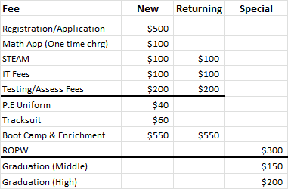

**Payments & Plans**

1. Registration Fee – $500 due upon acceptance
2. Adv Tuition/Placement – $600 due upon renewal (May/Jun)
3. All other Fees – $1,150 (new) or $950 (returning), due upon acceptance or Aug/Sep
4. Annual payment – 90.0% of $13,500 - $12,150, due Jul 1st
5. Semi-Annual payment – 92.5% of $13,500 - $6,244, due Jul 1st and Jan 1st
6. Termly payments – 95.0% of $13,500 - $4,275, due on Jul 1st, Nov 1st, and Mar 1st
7. Monthly payments – 100% of $13,500 - $1,350, due on the 1st of each month - July to April

**NOTE:**

* **Family discount for multiple students – 10% of Tuition**
* **Accounts 60 Days and over - Services are suspended and the payment plan must be provided.**

**The student returns to school when the account is brought under 30 days**

* **Accounts 120 Days and over - Will be referred to Debt Collector and account holder will bear costs**

**Please note that failure to meet financial agreement, may result in legal action against you.**

* **Extra curricular activities & residential expeditions are not included as they are on an optional basis**

*If you have any questions or requests, please email Mrs. Greyson at* [*admin@imabda.bm*](mailto:admin@imabda.bm)*.*

____________________________________________________________________________ [www.impactbda.com](http://www.impactbda.com) | 23 Berkeley Road, Pembroke HM 09 | 441-747-4621 | info@imabda.bm